### Manually Upgrade File-based Workshared Project

Upgrading files to the latest release of Revit is a task required for projects with schedules that span multiple years, or an activity required for archived files needed as part of a new scope of work. Upgrading files is not a single-handed task but requires the approval of both the Design Team and the Airport project management

Upgrading steps:

* Schedule the Upgrade and Notify Stakeholders  
  Notify all the team members about the date and time of the upgrade and ask all team members to synchronize their local files, relinquish ownership of all elements and close local files by the time of the scheduled upgrade. The central file will be unavailable to the users during the upgrade process.
* Confirm the Revit version and build number
* Revit files cannot be saved to earlier versions. It is required that all team members work in the same Revit version and build. The version and build of Revit used in the project needs to be documented in the BIM Execution Plan.  
  Project Revit Coordinators may upgrade the project files to a newer Revit version to take advantage of new features and to stay up to date with software changes when the project spans multiple years. Upgrading a model is a planned activity that needs to be coordinated with every team member and should be approved and scheduled by the project manager.  
  Contractors and consultants must notify the Airport prior to implementing new software upgrades to verify that the Airport can accept the upgraded deliverables.
* Delete or Archive local files  
  Advise all users to archive or delete all the local project files and folders stored on their local workstation.
* Unload linked files  
  Most projects are a collection of cross-linked multidisciplinary files. To avoid the temporary upgrade of linked file(s), open each model and unload each linked file prior to upgrading. Do not remove the links as this may compromise the View Template overrides and other graphic settings.
* Start upgrading the linked files first. Unless otherwise agreed, each discipline is responsible for their own file upgrade. Request upgraded versions of the contractors’ and consultants’ files and replace them on the project server.
* Launch a session of the intended version of Revit.
* Open the central file with “Audit” and “Detach from Central” checkboxes enabled.
* Detach and Preserve the worksets.
* Save the file as a new central file at the same network location. Check the following Save As options: Change the Maximum Number of backups to 10, Compact the File, Change the Thumbnail Preview to the Start View drafting view, and change the Open workset default to ‘Specify’. (See Figure below)

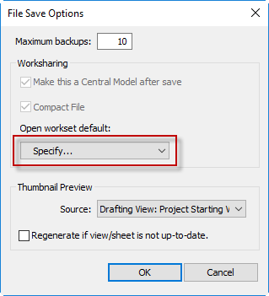

Figure 2.8‑1 Save Options

* Relinquish Ownership of all elements, save the file and close the central file.
* Reload the links.
* Once both the host and its linked files are upgraded, use the “Reload” button load the upgraded linked files.